**Mokito Exercises**

**Exercise 1:** Mocking and Stubbing **Scenario**: You need to test a service that depends on an external API. Use Mockito to mock the external API and stub its methods.

**Steps:**

1. Create a mock object for the external API.

2. Stub the methods to return predefined values.

3. Write a test case that uses the mock object.

**Code:**

package org.example;

public interface ExternalApi {

        String getData();

}

package org.example;

public class MyService {

    private ExternalApi api;

    public MyService(ExternalApi api) {

        this.api = api;

    }

    public String fetchData() {

        return api.getData();

    }

}

**package org.example;**

**import org.junit.jupiter.api.Test;**

**import static org.mockito.Mockito.*;**

**import static org.junit.jupiter.api.Assertions.*;**

**public class MyServiceTest {**

**@Test**

**public void testExternalApi() {**

**ExternalApi mockApi = mock(ExternalApi.class);**

**when(mockApi.getData()).thenReturn("Mock Data");**

**MyService service = new MyService(mockApi);**

**String result = service.fetchData();**

**assertEquals("Mock Data", result);**

**}**

**}**

**Output:**

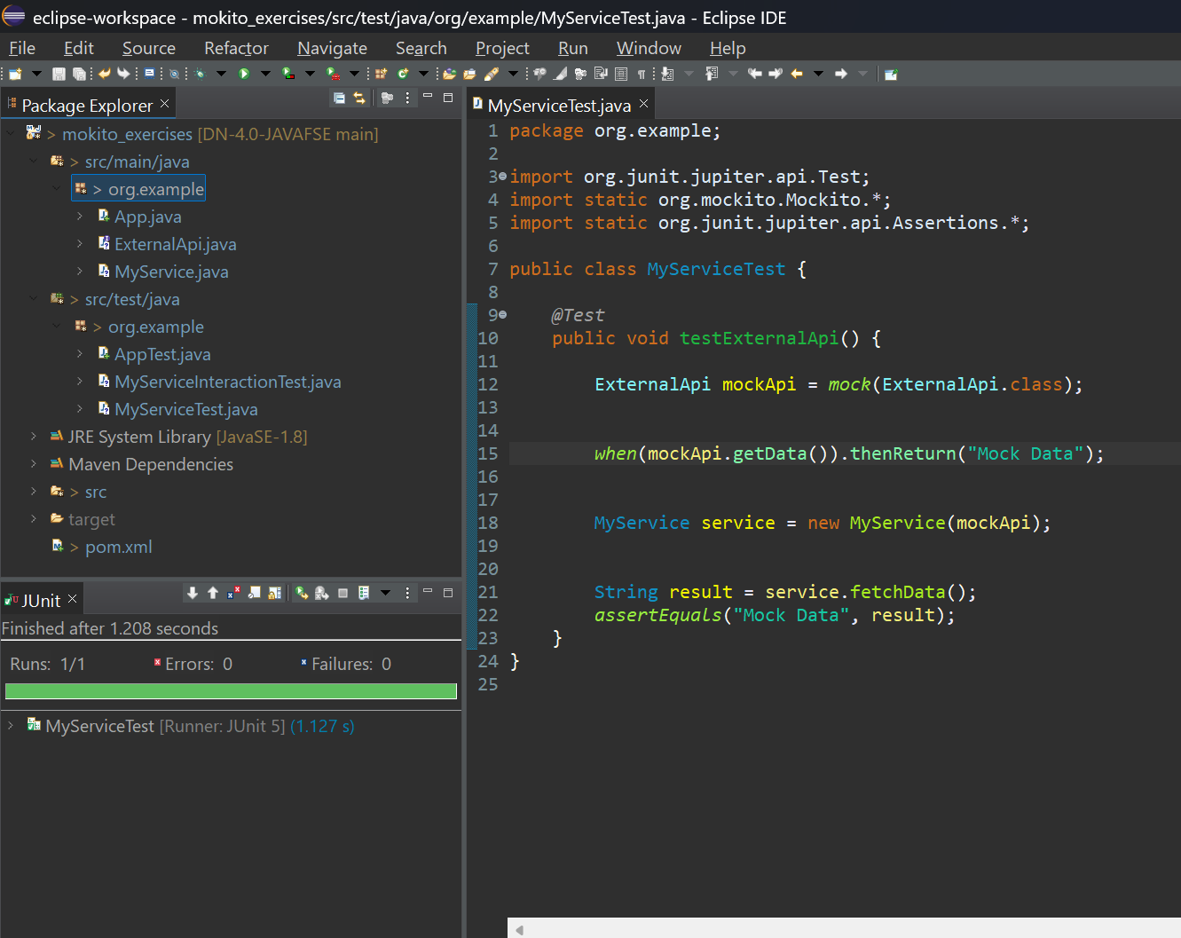

**Exercise 2:** Verifying Interactions **Scenario:** You need to ensure that a method is called with specific arguments.

**Steps:**

1. Create a mock object.

2. Call the method with specific arguments.

3. Verify the interaction.

**Code:**

package org.example;

public interface ExternalApi {

        String getData();

}

package org.example;

public class MyService {

    private ExternalApi api;

    public MyService(ExternalApi api) {

        this.api = api;

    }

    public String fetchData() {

        return api.getData();

    }

}

package org.example;

import org.junit.jupiter.api.Test;

import static org.mockito.Mockito.*;

public class MyServiceInteractionTest {

    @Test

    public void testVerifyGetDataCalled() {

        ExternalApi mockApi = mock(ExternalApi.class);

        when(mockApi.getData()).thenReturn("Mocked Value");

        MyService service = new MyService(mockApi);

        service.fetchData();

        verify(mockApi).getData();

    }

}

**Output:**

**For success test:**

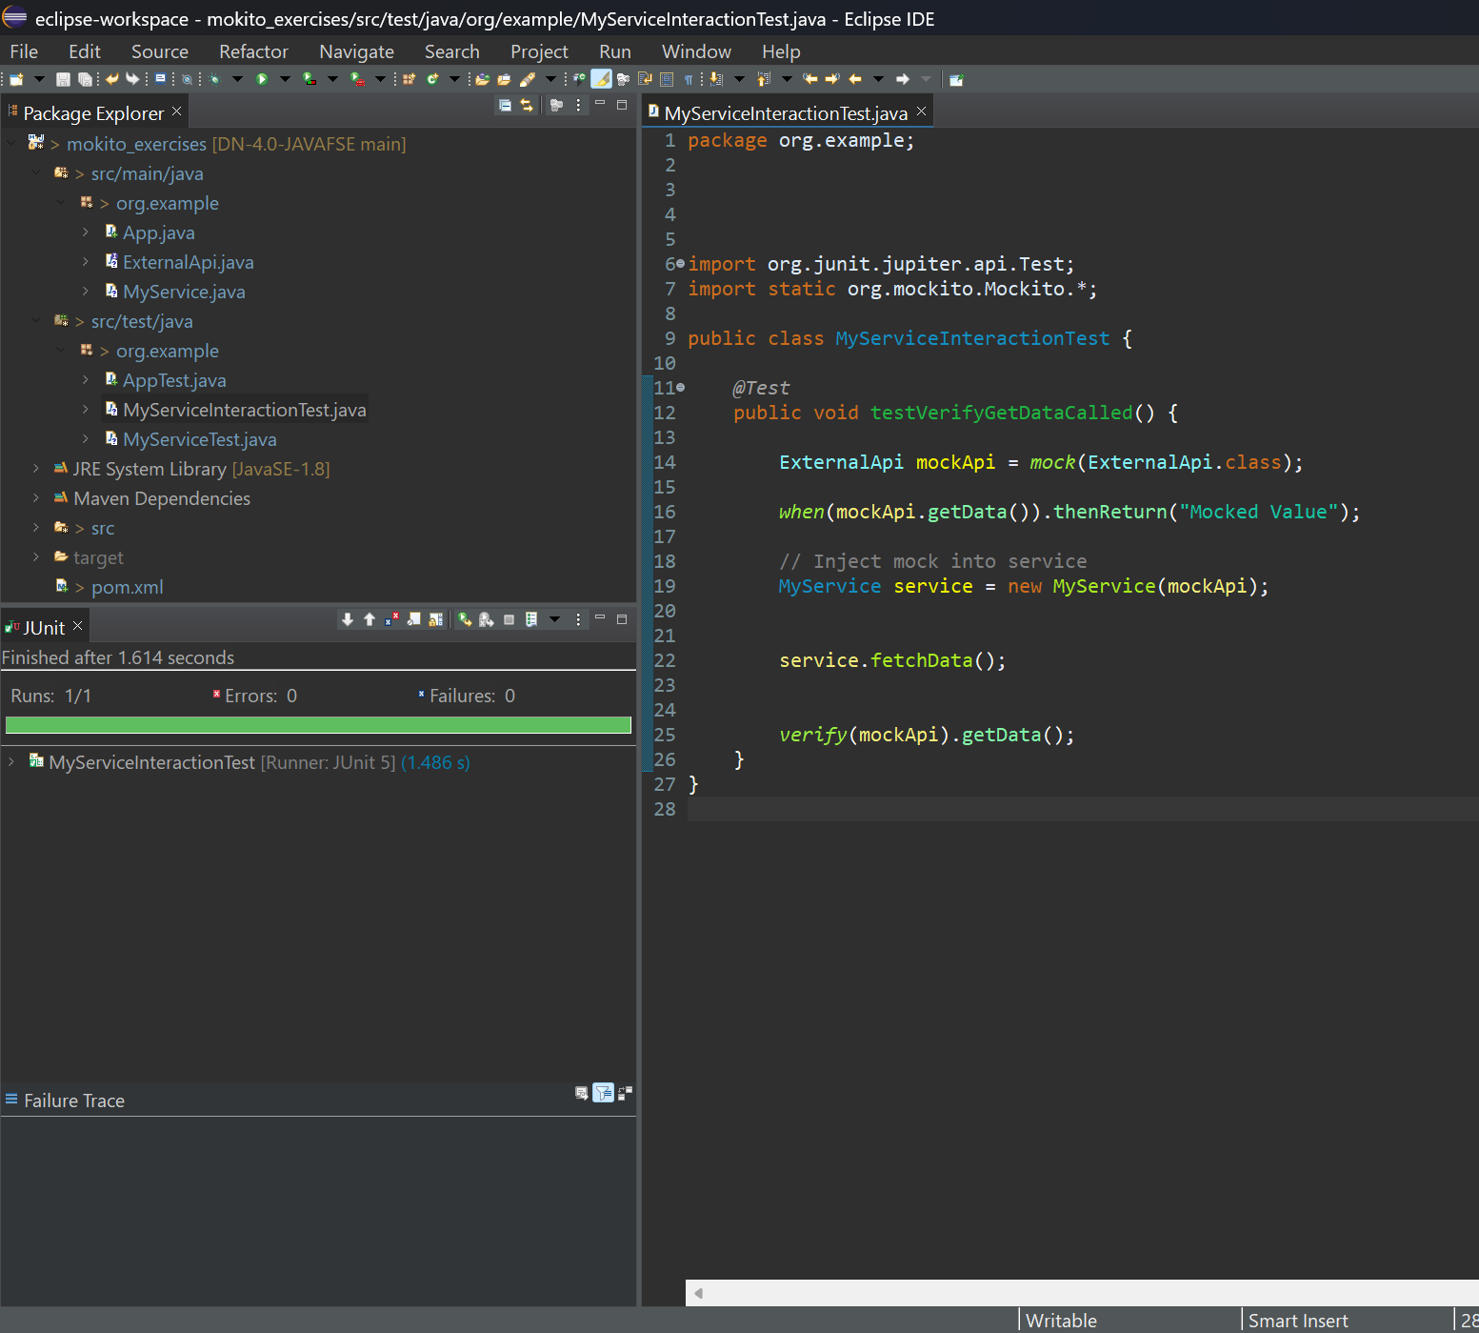

**For failure test:**

